Chapter 10, Solution 47.

Let 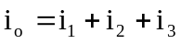, where , , and are respectively due to the 24-V dc source, the ac voltage source, and the ac current source. For , consider the circuit in Fig. (a).
(a)
2 H
4 W
1/6 F
1 W
24 V
2 W
i₁
- +

Since the capacitor is an open circuit to dc,
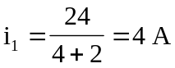

For , consider the circuit in Fig. (b).
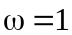
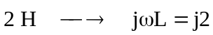
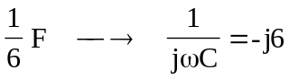
(b)
I₂
j2 W
4 W
-j6 W
1 W
10Ð-30° V
+
-
I₁
I₂
2 W
For mesh 1,
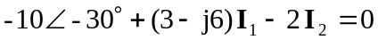
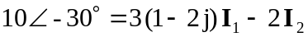 (1)

For mesh 2,
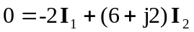
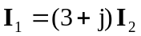 (2)

Substituting (2) into (1)
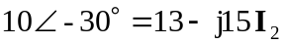
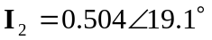
Hence, 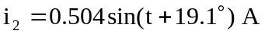

For , consider the circuit in Fig. (c).
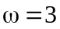
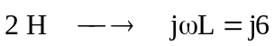
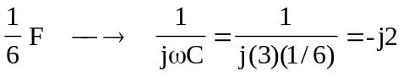
(c)
I₃
j6 W
4 W
-j2 W
1 W
2 W
2Ð0° A

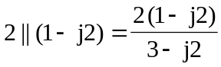

Using current division,
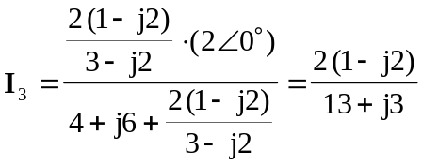
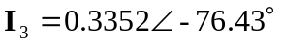
Hence 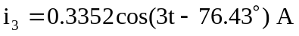

Therefore, 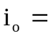 [4 + 0.504 sin(t + 19.1°) + 0.3352 cos(3t – 76.43°)] A

